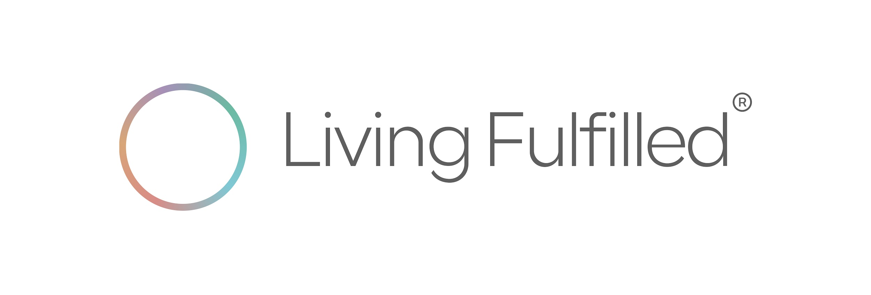

Living Fulfilled Scorecard

Guidance: This scorecard is used by the end user to indicate how your score for the questions below before and after you complete the program.

The most common and recommended convention is:
1 = Low
5 = High
So:
- 1 → very low / strongly disagree / poor / minimal
- 3 → neutral / average / moderate
- 5 → very high / strongly agree / excellent / maximal
This is the standard used in:
- Likert-scale surveys
- Most HR, wellbeing, and engagement assessments
- Executive dashboards and benchmarking tools

Why this matters
- It aligns with intuition: higher number = more of the thing
- It’s easier to interpret trends and averages
- It avoids confusion when reporting to C-suite or boards

Questions - please record your scores BEFORE and AFTER completing the program.

1 = Low
5 = High
BEFORE completing the program

Do I know what I can be the world’s greatest at? | Do I know what my best life looks & feels like? | Clarity about all aspects of my life | Productivity in general | Emotional wellbeing | Goal setting confidence
Score  ( X) | Score  ( X) | Score  ( X) | Score  ( X) | Score  ( X) | Score  ( X)

AFTER completing the program

Do I know what I can be the world’s greatest at? | Do I know what my best life looks & feels like? | Clarity about all aspects of my life | Productivity in general | Emotional wellbeing | Goal setting confidence
Score  ( X) | Score  ( X) | Score  ( X) | Score  ( X) | Score  ( X) | Score  ( X)

How to Use Your Living Fulfilled® Scorecard Results
Your Living Fulfilled® Scorecard is not a test or a pass–fail assessment. It is a personal insight and decision-making tool designed to help you consciously translate reflection into action.
By scoring yourself before and after completing the Living Fulfilled® program, you create a clear snapshot of how your clarity, confidence, and sense of direction have shifted. The value lies not only in higher scores, but in understanding why those changes occurred and how to act on them.
Use your results as a reference point you can return to at different stages of your life, career, or personal evolution.

Three Key Ways to Use Your Scorecard Results
- Identify what has shifted — and why
Compare your “before” and “after” scores to pinpoint where clarity, confidence, productivity, or emotional wellbeing has meaningfully improved. These shifts highlight which parts of the program unlocked insight, alignment, or momentum for you — and where your strengths are now clearer.
- Guide intentional decisions and priorities
Use areas with the greatest score change to inform your next decisions around career direction, life design, goal setting, and personal boundaries. Areas that remain lower are not failures; they signal where you may want to focus attention, deepen reflection, or revisit specific tools from the guide.
- Create an ongoing personal benchmark
Your scorecard becomes a living reference you can revisit during life transitions, annual planning, or moments of uncertainty. It helps you track progress over time, stay aligned with what truly matters to you, and ensure your choices continue to support the life you are intentionally designing.
In essence, the Living Fulfilled® Scorecard helps you move from self-awareness to self-leadership — using insight, not pressure, to shape a life that feels aligned, meaningful, and fulfilled.

###

